Pharmacy Inventory and Expiry Tracker

Program Definition
The Pharmacy Inventory & Expiry Tracker is a software application that helps automate the management of pharmaceutical inventory. It eliminates manual record keeping through a digital interface that tracks drug information, stock quantities, and expiration dates as they are updated. The software serves as a centralized decision-support system for pharmacists to mitigate stockouts and financial loss from expired drugs.

Objectives
1)To Automate Inventory: Eliminate manual errors in counting and recording stock.
2)To Minimize Waste: proactively identify medicines nearing their expiration date.
3)To Accelerate Billing: Reduce customer waiting time by automating price calculation and stock deduction.
4)To Ensure Data Integrity: Maintain accurate records of sales and purchases for auditing.

Expected outcomes
Upon completion, the system will deliver:
- A centralized database of all medicines available in the store.
- An automated "Alert Dashboard" highlighting items expiring within 30 days.
- A billing interface that generates receipts and automatically updates inventory levels.
- Sales reports helping the admin understand which products are in high demand.

Concepts Applied
To meet the academic requirements, this project applies the following core concepts:
- Object-Oriented Programming (OOP): Using classes for Medicine, Supplier, and Bill.
- Data Structures: Using Lists/Arrays for cart management and HashMaps (Dictionaries) for fast medicine lookup.
- Database Management (DBMS): Implementation of CRUD operations (Create, Read, Update, Delete) using SQL or File Handling.
- Algorithm Design: Sorting algorithms to order medicines by expiry date and Search algorithms to find items by name.

Requirement Analysis
Module 1: Stock Management (CRUD)
- Admin can Add new batches of medicine (Name, BatchID, Price, Expiry).
- Admin can Update stock levels when new shipments arrive.
- Admin can Delete obsolete records or zero-stock items.
Module 2: Billing & Transaction System
- System allows searching for medicine by name.
- User can add multiple items to a "Cart."
- System calculates Grand Total (Price × Quantity) + Tax.
- Critical Logic: Upon "Checkout," the system creates a sales record and decrements the Quantity in the inventory database.
Module 3: Analytics & Reporting
- Expiry Alert: Filters and displays items where Expiry_Date < (Current_Date + 30 days).
- Low Stock Alert: Displays items where Quantity < Threshold .

Non-Functional Requirements
1)Data Consistency: The system must ensure stock never goes below zero. A transaction must fail if Requested Quantity > Available Quantity.
2)Performance: Search results for a medicine must appear in under 2 seconds.
3)Usability: The interface should require minimal typing; usage of dropdowns for Categories to prevent spelling errors.
4)Security: Access to the "Delete Stock" function is restricted to the Admin user only (User Authentication).

Top-Down Design
This hierarchical structure shows how the main system breaks down into sub-modules.
- Level 0: Pharmacy Management System
  - Level 1.1: Authentication (Login/Logout)
  - Level 1.2: Inventory Subsystem
    - 1.2.1: Add Medicine
    - 1.2.2: View All Stock
    - 1.2.3: Remove Expired Items
  - Level 1.3: Billing Subsystem
    - 1.3.1: Search Item
    - 1.3.2: Add to Cart
    - 1.3.3: Generate Invoice
  - Level 1.4: Alerts Subsystem
    - 1.4.1: Check Expiry
    - 1.4.2: Check Low Stock

Algorithm Development:

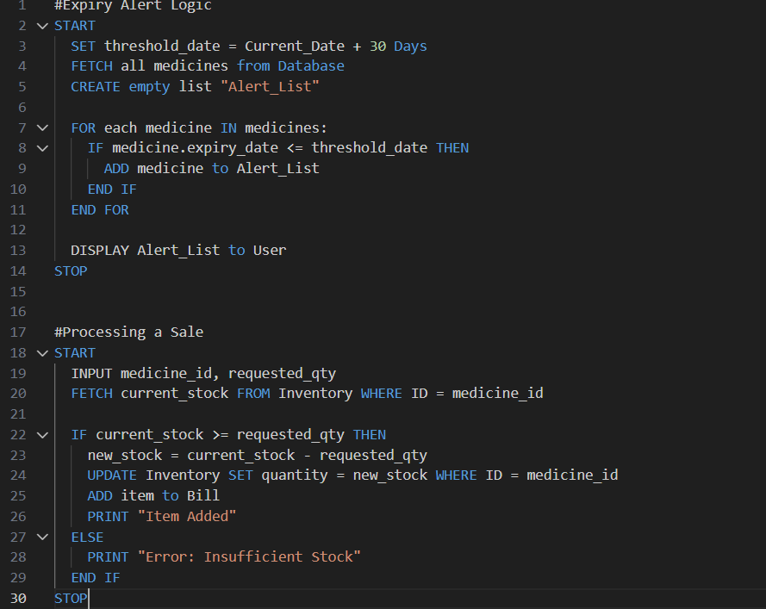

Implementation:
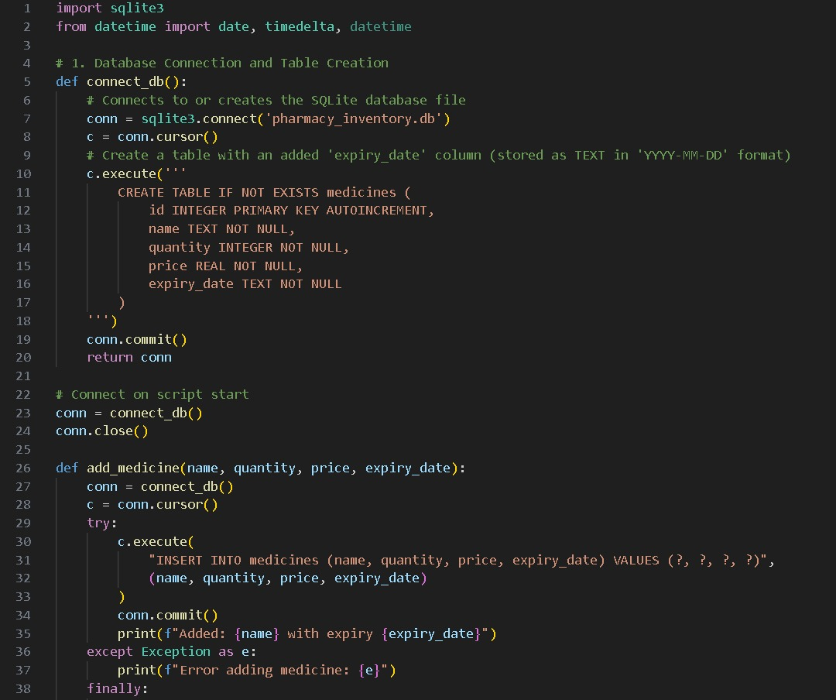
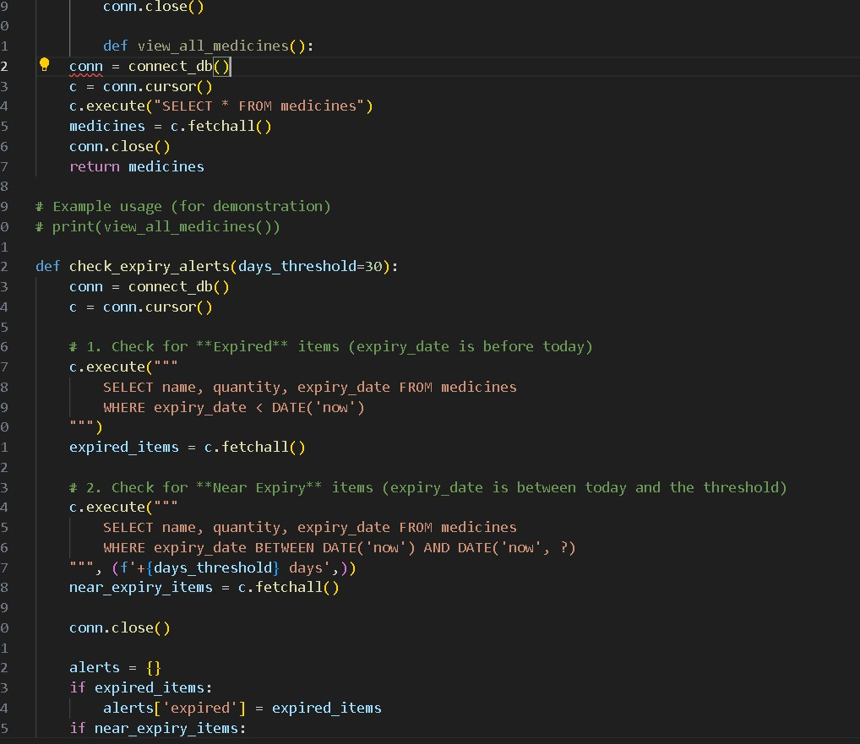

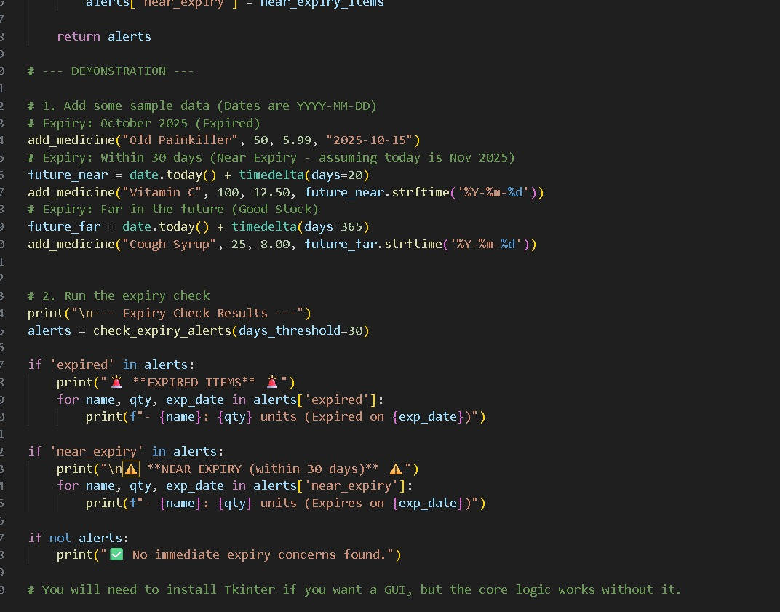

Testing and Refinement